Multitroniks Inc.
Installation Guide

LVX Laser Assembly System with Vision / Win 95 operating system
LVX Laser Conveyor Assembly System / Win 95 operating system
LVX Laser Assembly System / Win 95 operating system

All above models will be referenced as LVX unless otherwise specified.

Table Of Contents

Section 1 - Specifications

Section 2 - Installation
- Site Preparation
- Unpacking System
- Accessory Package Contents
- Cable & Air Hose Connections
- Applying Power to the System

List Of Figures

Figure 1: Site Preparation
Figure 2: Lifting Locations
Figure 3: Machine Foot Attachment
Figure 4: y-axis and z-axis Shipping Straps
Figure 5: Machine Highlights
Figure 6: Computer Cable Connections

Section 1 - Specifications

General:

- Dimensions: LxWxH: 41” x 43” x 59”
- Weight: 1,200 lbs
- Power Supply: 120 volts AC, 60Hz, 15 Amps (220 volts AC, 50/60Hz option)
- Air Supply: clean, dry air at 90 PSI, 3 CFM

Features:

- “On-the-fly” touchless laser centering
- Vision system for fine pitch alignment (optional)
- Linear glass scale encoder
- 3000 CPH (based on a ten inch diagonal travel)
- Microsoft ’95 Windows operating software
- Closed servo-loop motion control system
- Vision system for fiducial recognition
- Robust structure
- SMEMA Compatible: The LVX I can be configured as a stand alone system or multiple systems. A programmable conveyor system integrates the LVX I to other SMD lines.

Feeder Capacity:
Up to 96 (8mm) feeders (large feeders will decrease the total capacity, respectively, as will the use of the conveyor system).
Feeder types:
- For tape presented parts in 8, 12, 16, 24, 32, 44 mm sizes
- Vibratory feeders for sticks (fourteen standard size lanes and custom lanes)
- Adjustable waffle tray holders

PC Board Size:
- Maximum: 18” x 18”
- Minimum: as small as .5” x .5” with fixture.
- Larger sized boards can be accommodated using standard extension plates or on a custom basis.
- Standard holders for .06-.09 inch PCB Thickness. Optional holders are for .03-.06 inch and .09-.12 inch PCB Thickness.

Motion System

General:
- Servo Controlled Motors (all axes)
- Machine Accuracy: + .002 inch
- Machine repeatability: + .001 inch
- Placement repeatability: + .0015 inch

X-Y Axes:
- Encoder Resolution: .0004 inches
- Axis Accuracy: + .001 inch
- Range of Motion: 26 inches each axis
- Max. Velocity: 35 inches/s
- Max. Acceleration: 300 inches/s²

Theta Axis:
- Angular Resolution: + .025 degrees
- Angular Range: 0-360 degrees continual free rotation
- Max. Velocity: 8 rotations/s
- Max. Acceleration: 100 rotations/s²

Z Axis:
- Resolution: + .0003
- Stroke: up to 1.5 inch
- Max. Velocity: 20 inches/s
- Max. Acceleration: 200 inches/s²

Analysis:

Laser:
- Maximum Size Part Analyzed: 1.1 inch
- Analysis done on the fly.
- Use with all non-fine pitch parts.
- Minimum recommended pitch is 25 mil

Vision:
- Maximum Size Part Analyzed with Vision: 1.6 inch
- Use with all leaded parts and BGAs.
- Minimum recommended pitch is 20 mil

Nozzles:
- Five standard nozzles shipped with machine used for 0504 chips to large QFPs.
- Ten nozzle nest used for automatic tool change.
- Specialty nozzles available: 0402, Melf, mini-Melf, O-ring type, custom.

Options:
- Conveyor System
- Table Extension Plates
- Glue Dispensing
- CAD conversion software
Section 2 - Installation

Site Preparation

The Multitroniks LVX assembly system has been designed to use feeders on all four sides, and therefore requires placement away from any walls or other equipment. FIGURE 1 shows that a minimum of three feet (1 meter) is required on all sides for an operator to comfortably load or remove component feeders.

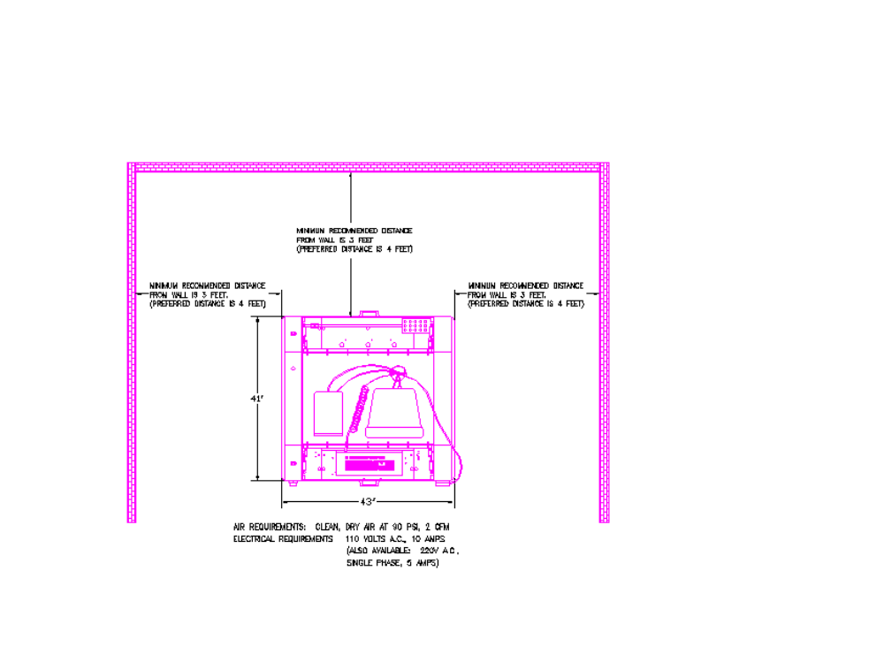
Figure 1

The floor that supports the LVX should be level and capable of supporting three to four times the weight of the machine itself. This is primarily due to inertia genereated by the movement of the X and Y axis of the machine. Insufficient floor support may cause excessive “shaking” of the machine during normal operation. The machine frame is in a weight range where it can not be moved by hand and requires the use of a fork-lift or pallet jack. It is recommended that the LVX be located on a ground floor level because of the added difficulty of lifting or supporting the machine to above ground floors. Be sure to remove side panels before lifting to prevent damage.

Unpacking the Assembly Machine

The Multitroniks LVX Surface Mount Assembly system has been shipped to you in two crates. The larger crate contains the main assembly system, and the smaller crate contains the computer and all accessories.

- Remove the sides and top from the larger crate.

- Remove the protective plastic wrapping. Be careful not to scratch the machine when cutting packaging material. Inspect and report any significant damage immediately to MultiTroniKs.

- Pull open the scrap collection drawer, located in the rear access panel.

- Locate the black plastic rail locks which are located on each slide rail of the drawer. Snap both left and right rail locks up and lift the drawer up. When the drawer has been unlocked from the slides, remove the drawer by pulling it straight out.

- The front, rear, and side panels are attached with hook-and-loop fasteners “Velcro”. Remove the front and rear panels by first pulling out the bottom and then sides of the panel.

- Using a socket wrench, remove the nuts on the two shipping brackets which hold the machine frame to the shipping skid.

- Raise the machine off the skid using a forklift. Be sure that outer panels are removed since the panels hang beyond the bottom of the cross-members. Be sure that the forks extend beyond the cross-members by a few inches. (SEE FIGURE 2).

- Move machine to final position.

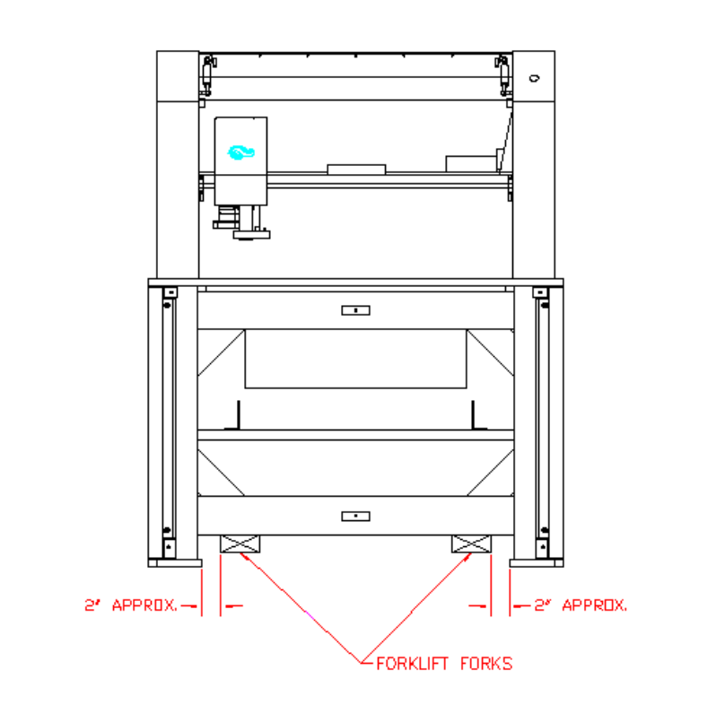
FIGURE 2

- Before lowering the machine to the floor, attach the 4 leveling pads into the holes located in the leveling pad mounting plates. Be sure to leave about one inch of the threads exposed between the leveling pad and the plate to allow for minor adjustments in either direction. (SEE FIGURE 3).

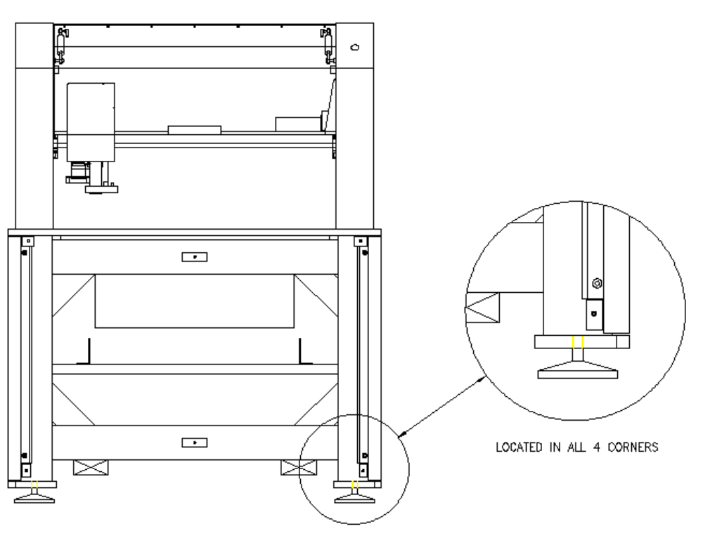

FIGURE 3

- The lock nut should be located halfway between the full lower and upper stop points so that it turns freely, and yet does not block the ‘flat’ edges of the threaded foot bolt.

- After lowering the machine to the floor, adjust the 4 feet by turning the flattened part of the foot bolt with a wrench so that the machine base plate is level and the machine does not rock.

- Tighten the locking nuts up against the mounting plate.

- Notify MultiTroniKs Service department that the machine is in place and ready for setup by a Field Engineer.

- Save all crating and packaging materials unless otherwise instructed.

Unpacking the Accessory Package Crate

The accessory package contains the computer system and all the standard and optional accessories ordered with the assembly system. Please compare your packing list with accessories provided. If you are not familiar with the items, ask your MultiTroniKs Field Engineer to confirm your order for you. Note that this section will only describe the set up and use of the standard items and is generally done by a Factory Trained Representative.

- Remove the top from crate

- Remove the computer, keyboard and monitors from their shipping boxes.

- Remove the front and rear panels from the machine.

- Remove Hook and Loop fasteners from one end and slide out the electronics cover plate.

- Slide the computer in from the front of the machine with the computer facing you.

- Connections to the PC will be labeled on both the PC and the cables. Observe polarity and secure all connections to the PC. Note: An additional cable may be present that is not used. This was previously used for a jog pendent that is now software driven.

- Mount the keyboard onto hook and loop fasteners attached to the Plexiglas cover.

- Place the computer monitor and video camera monitor screens on the top of the machine facing the front.

- Remove the three of the six 1/8” button head cap screws from Cable Access Plates located on the top rear side of the machine. Note: only one of the half circles need to be removed for sufficient access.

- Feed the keyboard, monitor and power cables neatly into this hole.

- Replace Cable Access Plate.

- From the Front of the machine, open the Plexiglas cover and loosen by about three turns the four screws which secure the ceiling panel to the top of the machine.

- From the rear side of the machine, open the Plexiglas cover and remove all four screws which secure the ceiling panel to the top of machine.

- Carefully move the Placement Head to the middle of the machine.

- Gently Pulling down the ceiling panel from the rear of the machine you will notice female connectors for your associated peripherals. Be sure to secure all connections.

- Secure ceiling panel.

- Place Calibration component into holder on the front right side of the machine. Be sure the Black side with the white circle is facing up.

- Remove the CyberOptics laser from its packaging and secure it to the mounting bracket so that this laser ‘surrounds’ the nozzle holder. NOTE: The hex head mounting screws are metric for this item. Connect the white coaxial cable to the laser.

- Remove nozzles from their packaging and insert them in sequential size order (largest to smallest from front to rear respectively) into the nozzle magazine located at the front left side of the machine. The magnets will self align these nozzles. Be sure that the smallest nozzle is toward the back of the machine.

- Carefully manually move the head to the far points of all axis, be sure that there are no obstructions. Observe limit switches and sensor flags for proper actuation. Be sure to leave the head in the center of the machine when done.

- Connect power cord to machine, connect male end to a high quality power filter/surge protector.

- Be sure all emergency stop switches are up (off) and the head is in the center of the machine.

- Start Machine by turning the green power button. Be sure that the PC and Monitors switches are also on.

- The Windows 95 desktop should appear with an Icon labeled either Multitroniks or LVX. Click on this Icon to start machine program.

- The machine will initialize all motors.

- Connect Air to the machine and adjust main vacuum to 85-90 PSI. The vacuum generator must be turned on while adjusting the regulator (turn on/off in the I/O Test menu).

- Adjust Blow back pressure to 6 PSI. The blower must be turned on while adjusting the regulator (turn on/off in the I/O Test menu).

- Be sure to use standard “Windows” operating procedure when shutting down the machine. All programs should be exited before powering down the system.

- Replace the panels.

- Replace the scrap drawer.

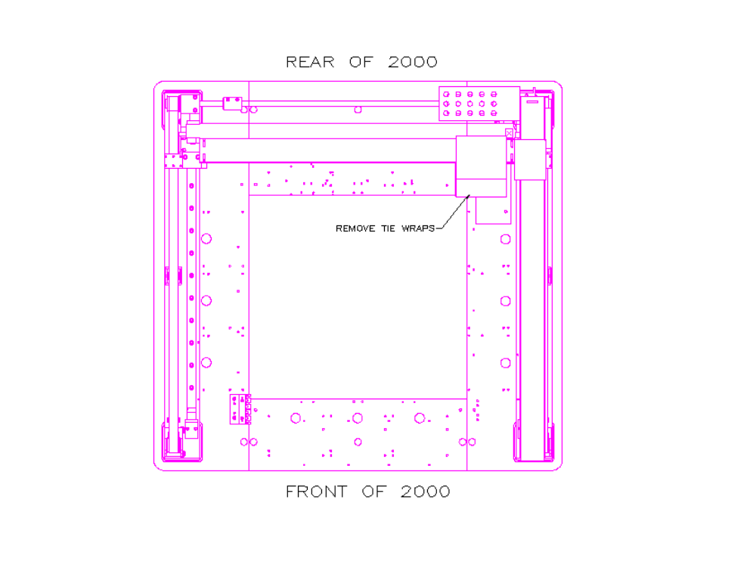
FIGURE 4

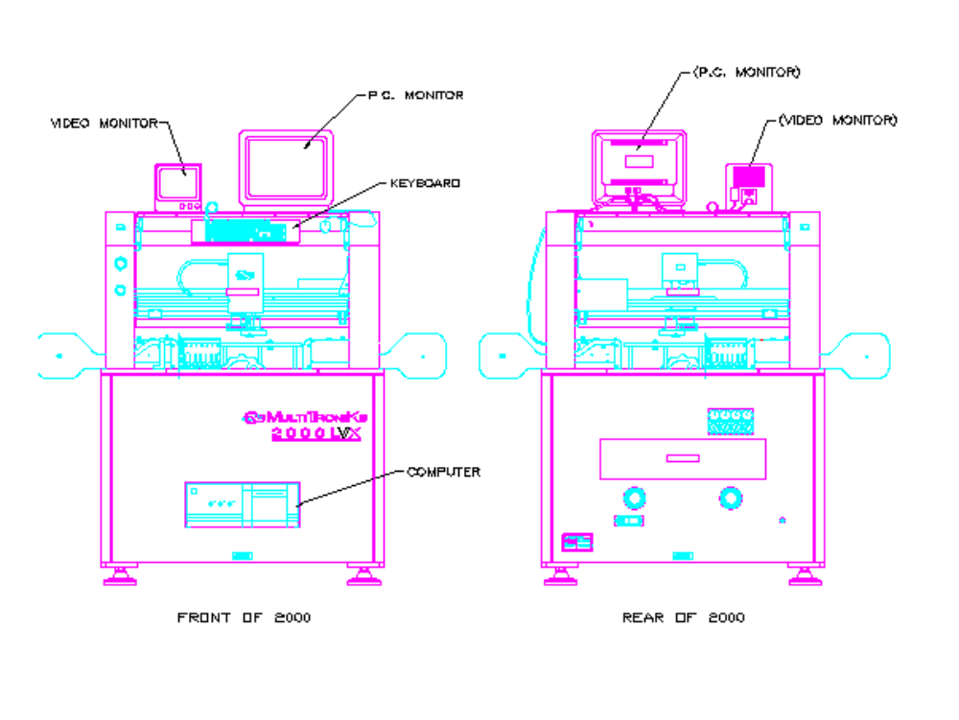
FIGURE 5
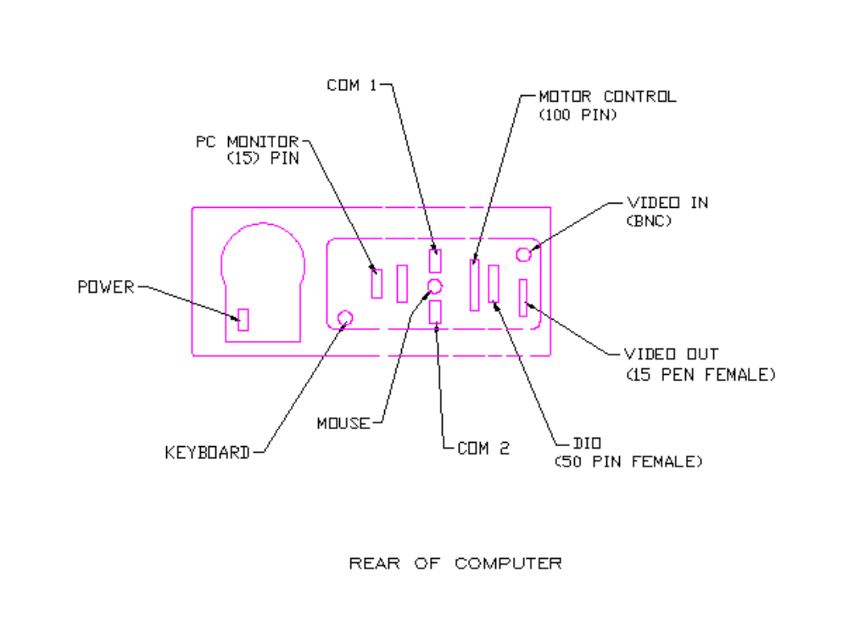

FIGURE 6

